Status:  Mr Peter Davey  Member of the Institution of Analysts and Programmers.  Ex-Artificer, RN.  Married, three children. | 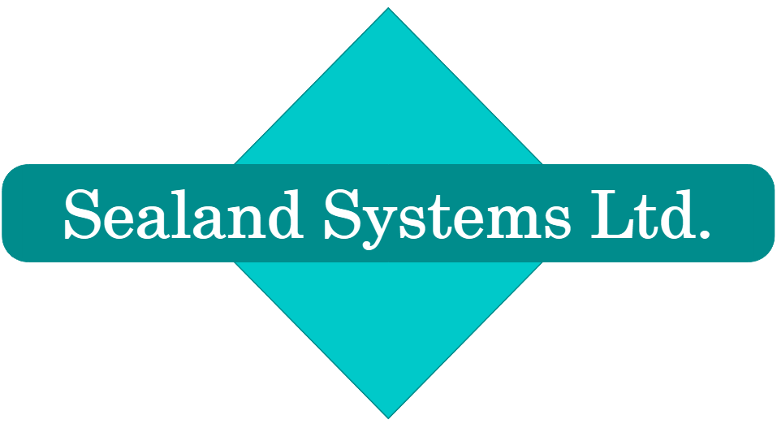  Address:  Sealand Systems Ltd  56 Monks Close  Lancing psvdavey@sealand-systems.co.uk  West Sussex Tel: +44 1903 209367  BN15 9DB GSM: +44 7802 651892

Experience and Achievements
A skilled engineer, with a wealth of real-world experience to get the job done, and used to being dropped in the deep end. Following Royal Navy service as a Chief Petty Officer (senior radio and computer technician) then a short period of voluntary work before five years in industry and business, Mr Davey now provides consultancy and technical support of server and network systems ashore, and electronic survey and navigation equipment at sea through his company, Sealand Systems Ltd. Sealand's contracts have included both technical support, and planning and installation of systems including Cisco, Novell, Windows Server and desktop, Unix, Solaris, Red Hat and SuSE Linux, and associated networking infrastructure.
Experience includes management and on-job training of less senior technicians, and a period as a technical instructor in the Royal Navy Submarine School while setting up a new training facility. Work included maintenance of radio communications, cryptography and navigational equipment including satellite systems and radar and various computers from Minis (e.g. HP1000, PDP11) to pre-PC programmable desktop “calculators” (e.g. HP9825) and embedded systems. He took a particular interest in computing and served in a number of computer-related positions including the Fleet Software Issuing Office, and commissioning and managing an early office PC network in 1985. During this period he also developed or rewrote a number of bespoke database systems, utilities and networked utility and email systems. His last position was as manager of the RN Submarine School's Novell network (having provided advice and support before it was installed).
After a break for voluntary work he moved to Industry, with four years in a manufacturing environment as Systems Administrator (and IT Manager) taking a very hands-on approach to both managing an MRP system on HP-UX and Informix, and architecture and management of the company's multi-site network with Windows and Novell servers. He designed and implemented the company's first bar-code system, tracking parts and stock from assembly line to warehouse to shipping, and wrote various other utilities and support software in several languages. He then spent eighteen months as an internal and customer consultant with a smaller local company which assembled, developed and marketed specialist PC systems and music studios for schools and colleges and provided InSeT for teachers.
He has implemented the planning, procurement and execution of a number of projects, including authorship of documentation. His training and experience make him able both to supervise and to deal hands-on with every level of systems from software through to hardware installation and component-level repair.

History
Since 1999, Sealand Systems Ltd. Mr Davey is employed by his consultancy which provides professional services in the UK, and beyond, including architecture, installation, support and occasional supply of critical computer and network solutions, and support of specialist survey and navigation equipment offshore. Our most recent major client was Windows / Red Hat / Cisco. We use Windows / Linux in our own office.
Contracts:
2012 to date Ad-hoc local business and a series of contracts with our offshore clients. Details of this specialist offshore work are outside the scope of this CV but can be found at http://sealand.systems/personal
2019 Pursuing CCNA accreditation.
Throughout 2018 Periods supporting IT and mostly HP Aruba network in offshore cable lay vessel Maersk Connector.
May 2017 Cisco network consultancy (C2911/K9, C2960S, IOS image updating, running configuration review and alteration, faultfinding) during commissioning at BP’s Clair Ridge platform. An unusual one, this – performing the normally shoreside role offshore.
February 2013 A short contract configuring Cisco switch and ASA devices for HMRC.
February 2009 to January 2012 Roke Manor Research Repeat client from 2007 and 2008. Design, installation, configuration, documentation and support of Cisco catalyst switch/routers, ASA/PIX/Vyatta firewalls, Juniper Secure Access (SSL VPN), Red Hat Linux cluster, Kickstart, Windows on Intel servers and Brocade/EMC SAN, for the front end of the London Congestion Charging and Limited Emission Zone systems (security cleared).
Through repeated contracts with the client starting with responsibility for hardware installation in 2007, Mr Davey supported this system through its full life-cycle. As a result of being invited back for different phases of the project, he became involved in design (including production and upkeep of detailed design and operations documentation), upgrades and DR data centre migration, and concluded with third line support of the project after the development teams disbanded, becoming the subject matter expert on the server hardware, SAN, network and firewall rule-sets.
December 2008 – January 2009 Survey Engineer – CLB Installer. Gunfleet Sands Wind Farm.
May – November 2008 Roke Manor Research (see April 2007 and February 2009).
February – April 2008 Acergy Group and DOF Subsea Contracts for vessel co-ordination and survey support.
December 2007 – January 2008 Dell Solutions Ltd. Carrying out Windows domain and Notes to Exchange (client side) email migrations for a large Dell customer.
April – September 2007 Roke Manor Research (see May 2008 and February 2009).
2006 – March 2007 A series of contracts providing survey technical support in ships constructing the major Ormen Lange gas field.
2004 – 2006 Cognotec. A further contract of 19 months planning and executing projects installing Sun Solaris gateways for foreign exchange rates feed on behalf of previous client Cognotec Ltd, for bank customers in London, Brussels, Stuttgart, Frankfurt, Düsseldorf, Copenhagen, Åbenrå, Vienna, Athens, Bratislava, Tel Aviv. Technical liaison, debugging Triarch/Tibco feeds, LAN/WAN, routers and firewalls and installing the dealing-room SBT application. Visits to client’s customers included planning meetings, new installations, upgrades and problem investigations. Integration of Cognotec’s solutions with customers’ Single Sign On (SSO).
2001 – 2004 Various clients – Windows 2000 LAN/WAN consultancy and reconfiguration. Switched VLAN network / NT / WINS / DNS consultancy for a South London school. Linux/MySQL support. Survey Engineering (installation, technical support and operation of specialist equipment and computers) in a number of vessels for different companies in the North Sea, West Africa, Egypt, Gulf of Mexico, North Atlantic (offshore contracts are of very varying length and often at short notice). NT / 2000 / Exchange / Novell / Cisco / SonicWall / GroupShield support for a direct-selling holiday company. Team-leading for a bank's PC rollout.
Summer 2001 Paternity leave, and six weeks network and server (NT and W2000) consultancy and evaluating a package delivery product for Counterpoint MTC Ltd.
2000 – 2001 Six months with Cognotec – major banks in seven European countries (see 2004 – 2006)
2000 The Caravan Club Managing Technical Support. Disaster Recovery planning. (HP-UX, NT, Exchange)
1999 – 2000 BSW Timber plc. A one year contract upgrading Novell and supporting HP-UX and Linux with Informix.
1999 Site visits and instructional work for Counterpoint MTC; support of off-shore survey spread installations aboard MV Toisa Puma and MV Seaway Invincible.

Before incorporation of Sealand Systems Ltd.
1997 – 1999 Counterpoint Music Technology Consultants – Internal and customer-facing consultant.
1993 to 1997 B&W Loudspeakers Ltd – Unix (HP-UX) and Novell Systems Administrator and three months as IT Manager.
1993 MV Doulos – Five months voluntary work in Cape Town refitting the world's oldest operational ocean liner. It's even more interesting than it sounds.
1972 – 1993 Royal Navy – Leaving as a Chief Petty Officer, YachtMaster and manager of the Submarine School's Novell Netware network.

Key Areas necessary for automated searches (if you do not find your key word here, please ask)
Hardware – HP9000, Sun, Dell, RAID, HP Netserver, HP JetDirect, Cat 5 UTP structured cabling and telephone system (Centrex) installation, Synoptics, Bay (Centillion) 5000 chassis and 58000 switch, Bay, Cisco, and 3COM routers, ISDN, kilostream, megastream WAN connections, firewalls, modems, RSA SecureID, EMC SAN, Synology SAN.
Networks – Twenty years designing, running and troubleshooting CSMA/CD networks, switched Ethernet, Cat 5 UTP, Fibre, IPX and TCP/IP, Watchguard Firebox, Dell Sonicwall, Juniper, Vyatta, HP Aruba & Procurve, Cisco Catalyst / PIX / ASA, routing, HSRP, VPN, proxy, firewall, DNS, NDS, DHCP, WINS, NTP.
Systems – MSDOS 2.11 to 6.22. Windows Server, AD Active Directory, XP, Terminal Server / Citrix, MS Exchange. HP-UX, SunOS / Solaris, Irix, Linux, Red Hat / Kickstart, SuSE, Ubuntu. Novell Netware from 2.15 to 5.1. NDS eDirectory, NDPS, Zen, NAL, ConsoleOne, BorderManager VPN and Web proxy, Standby Server, EMC, Brocade SAN. Documentation technical writing.
Development – Assembler, C, BASIC, HPL, Pascal, Python, Perl, Unix shell (bash) and awk scripts, DOS Batch. MS Access. Netware client API. Data transfer and migration between different systems, SQL work.
Applications – MS Office (Word, Excel, Access), Visio, WordPerfect, 1-2-3, OpenOffice.org, MySQL, Informix, Backup (Arcserve, Veritas, TapeWare), Web browsers / HTML editors, many DOS and Windows utilities, Sage Line 50, Sophos, GroupShield, SonicWall. Development / debugging of bespoke applications.

Education, Awards and Qualifications
Secondary education Boundstone Comprehensive School, Sompting, Sussex.
GCE O-levels: Physics (G1), Maths, Chemistry, French, English language. CSE (G1) Music.
Further education Royal Navy Apprenticeship. ONC in Electronics (distinction), RADAR, Communications and Maths. Qualified as Radio Engineering Artificer (Technician Engineer), gaining the workshop prize and prize for best results in final examination.
Novell System Manager's Course. (ITEC, Portsmouth)
Awarded the Diploma in Computing by the Open University, including third level course “Data Models and Databases”.
MS SQL Server 6.5 course (ICS, Basingstoke), Optivity for OpenView course (Bay Networks, Maidenhead)
Pursuing CCNA accreditation.
Other British passport
Full UK driving licence
Cogent/OPITO/OLF BOSIET UK/Norwegian Offshore Safety training and medical certificates.
OPITO MIST certification
C&G 15th Edition IEE wiring regulations.
RN Basic and Intermediate fire-fighting courses, Instructional Technique course.
RYA/DoT Yachtmaster, RN length of service and good conduct medal.

Other information
Interests Church and family life. Leading inland and offshore sailing expeditions. Music and sound recording.
Updates to this document can be downloaded in various formats from http://sealand.systems/personal

